Project Report: COVID-19 Data Analysis Using SQL and Power BI

Project Objective
The goal of this project is to perform exploratory data analysis (EDA) and create an interactive dashboard for COVID-19 data (2020-2023) using Microsoft SQL Server and Power BI. The analysis focuses on vaccinations, demographic impact, mortality rates, and comorbidities to provide insights into the global effects of the pandemic.

Tools and Technologies
- Database: Microsoft SQL Server
- Visualization: Power BI
- Data Modeling: Star Schema with Fact and Dimension Tables
- Data Sources: COVID-19 case, vaccination, and demographic datasets

Data Model
The data model follows a structured approach:
- Fact Tables:
  - COVID-19 Cases (cd23)
  - Vaccination Data (cv23)
- Dimension Tables:
  - Dates (dates)
  - Locations and Population (pk_location_and_population)
  - Continents (continents)
  - Miscellaneous Attributes (cv23_misalanaceous)
- Relationships are set using unique keys (iso_code, location, and date).
(Refer to the attached data model image for detailed relationships.)

SQL-Based Exploratory Data Analysis
Key questions addressed:
- First Vaccination Drive Conducted By: Identified the first country to start the vaccination campaign using SQL queries.
- Mortality Rate: Calculated mortality rate as a ratio of deaths to cases.
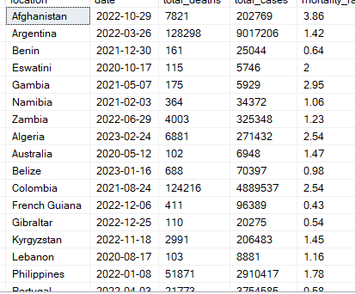
  - Reaching Milestones in Vaccination:
  - India's milestone dates for 25%, 50%, and 75% vaccination coverage.
  - Global milestones for vaccination rates.
- Weekly Average of Cases and Deaths: Used rolling 7-day averages.
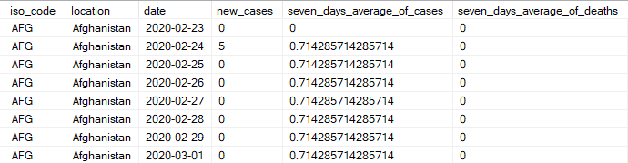

- Countries with Case and Vaccination Data Available: Filtered for countries with complete datasets.
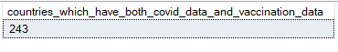
- Total Vaccination Per Capita for India: Calculated as vaccinations per million population.
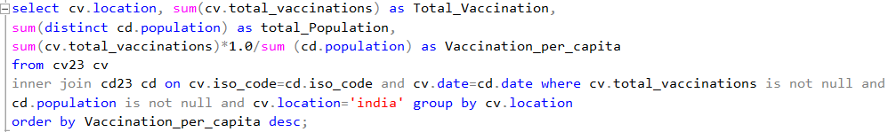

Power BI Dashboards
1. COVID-19 Analysis Dashboard
- Global vaccination count: 10.84 billion doses.
- Total cases: 763.13 million.
- Total deaths: 7 million.
- Mortality rate: 0.90%.
- Key visualizations:
  - Global map with affected regions.
  - KPIs for vaccinations, cases, and deaths.
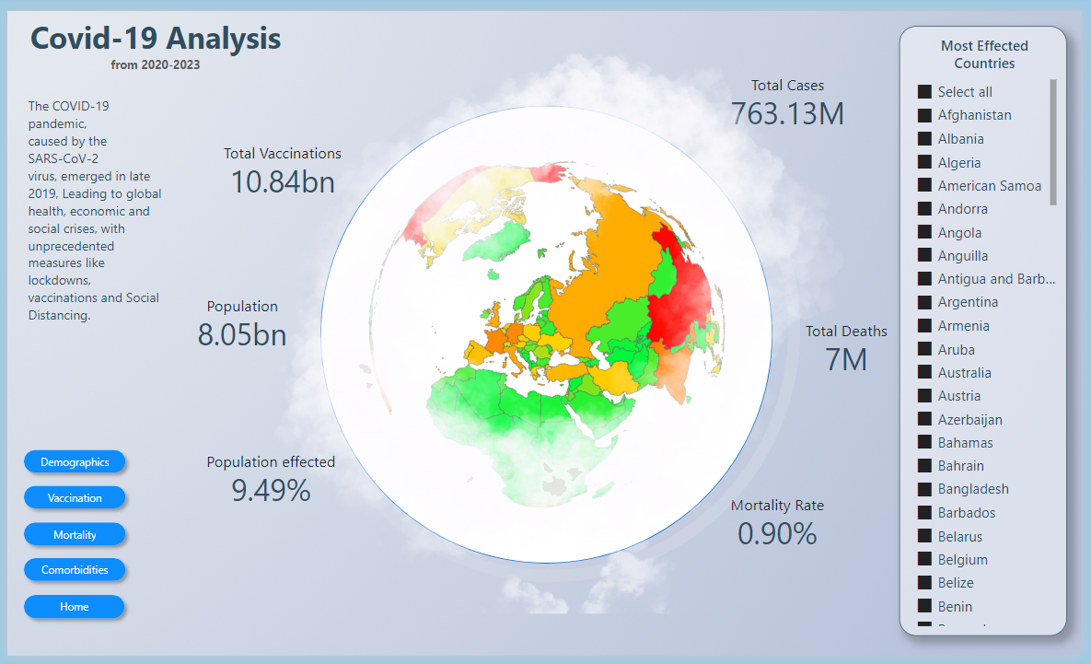

2. Demographic Analysis
- Relationship between age groups and mortality rates.
- Scatter plot for population density vs. cases per million.
- Demographic breakdown by continent
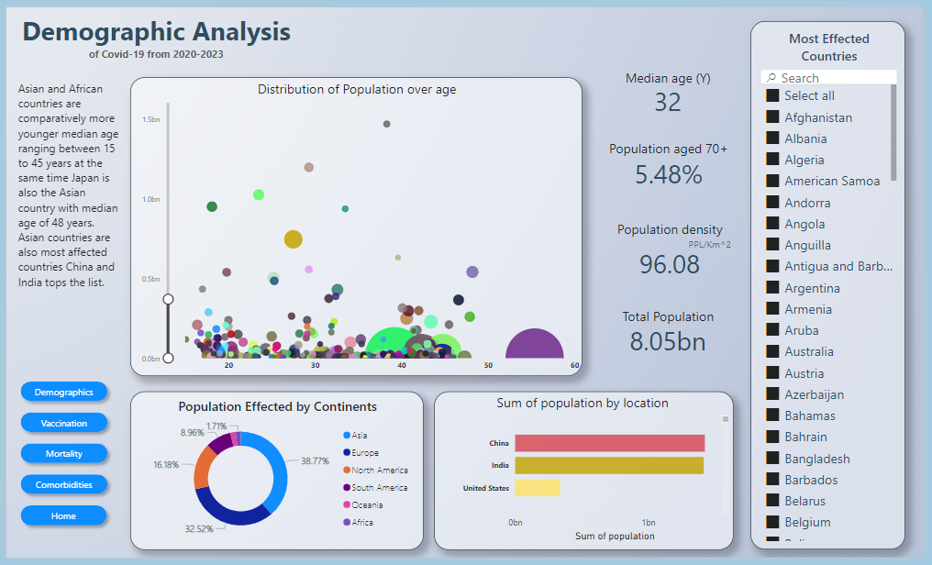.

3. Vaccinations Analysis
- Daily vaccination trends.
- Milestone achievements by country.
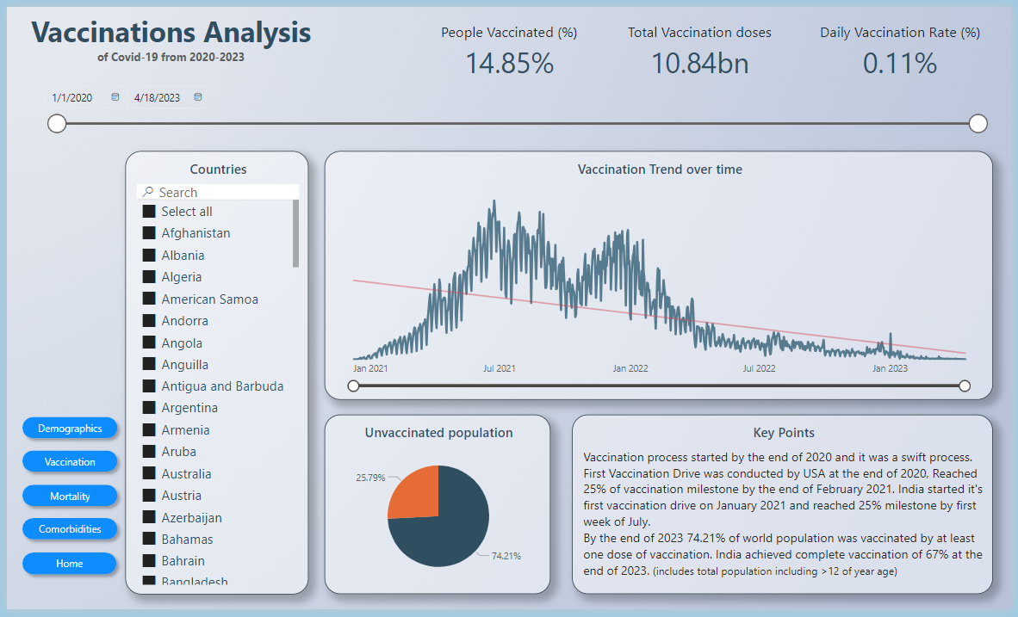

4. Mortality Analysis
- Geographic distribution of deaths.
- 857.61 Death reported over every 1 million of population.
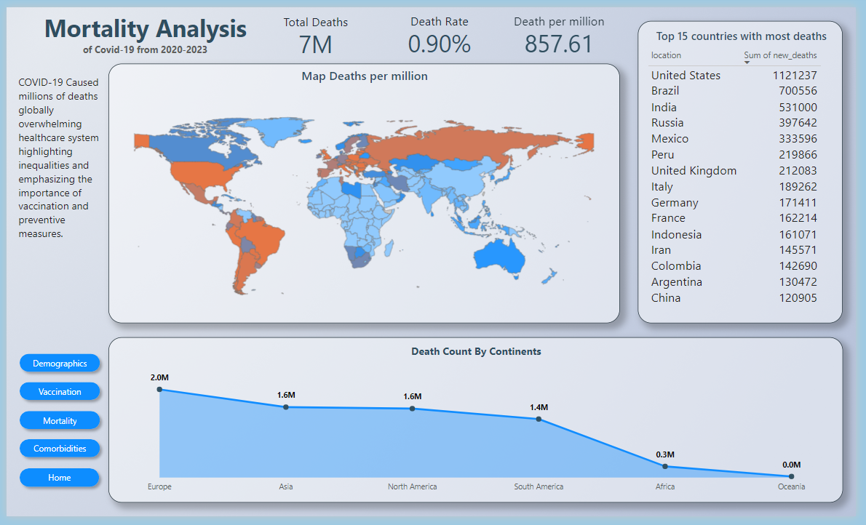

5. Comorbidities Analysis
- Cardiovascular death rate: 0.75%.
- Diabetes prevalence: 0.03%.
- Smokers percentage: 0.09%.
- Scatter plot for comorbidities vs. mortality rates.
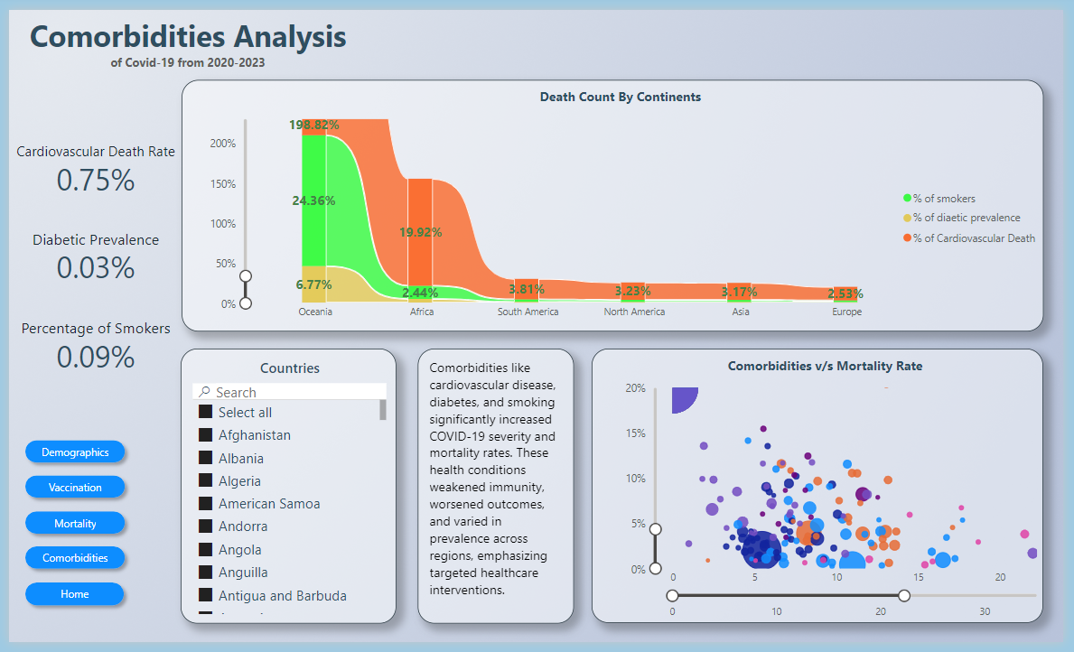

Insights Gained
- Vaccination Impact: Countries with higher vaccination rates showed lower mortality rates.
- Global Trends: Europe, Asis and North America had the highest mortality rates.
- Comorbidities: Cardiovascular diseases and diabetes significantly influenced mortality rates.

Conclusion
This project highlights the power of combining SQL and Power BI for robust data analysis and visualization. It provides actionable insights into the COVID-19 pandemic, emphasizing vaccination efforts and their global impact.
Future Enhancements
- Integrate real-time data updates.
- Include machine learning models for predictive analysis of future pandemics.
- Add sentiment analysis based on global COVID-related news data.

----------------------END-----------------------

